Blackie is an approximately 9 yr old MC DSH cat that was hit by a car. He is presented to you by the owner who found him in the road.

Physical Examination:
Body Weight: 4 kg
Hyper, alert, responsive; vocalizing
Mucous membranes –pink, 3 sec refill time,
Rectal temperature – 102.2
Eyes – WNL
Ears – brown waxy debris AU
Nose – WNL
Oral cavity – WNL, teeth – mild tartar, no gingivitis, freshly chipped tooth
Peripheral lymph nodes – WNL
Heart – no – Rate: 180 bpm
Lungs – auscultates WNL, rate – 30
Abdominal palpation – mild tension of caudal abdomen
Musculoskeletal – somewhat painful when palpated, ambulates on all four limbs; reaction elicited by palpating near the tailbase; palpation of extremities showed no obvious fractures
Integument – normal coat; some mild tenting of skin (estimate 5% dehydration)
Nervous system – because of pain, only an abbreviated examination was possible and showed normal patellar reflexes.

The owners have given you a budget of $500 to stabilize the cat, determine its prognosis and develop but not implement a treatment plan.

You take whole body radiographs (VD and lateral). They are shown below:

LATERAL 1 RADIOGRAPH
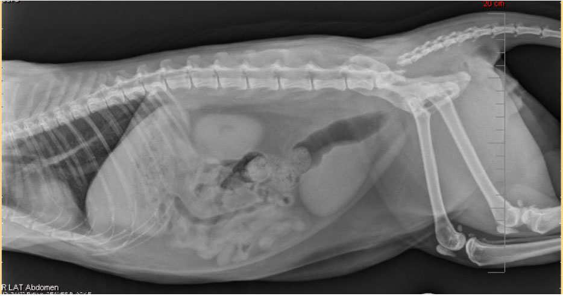
VENTRODORSAL 1 RADIOGRAPH
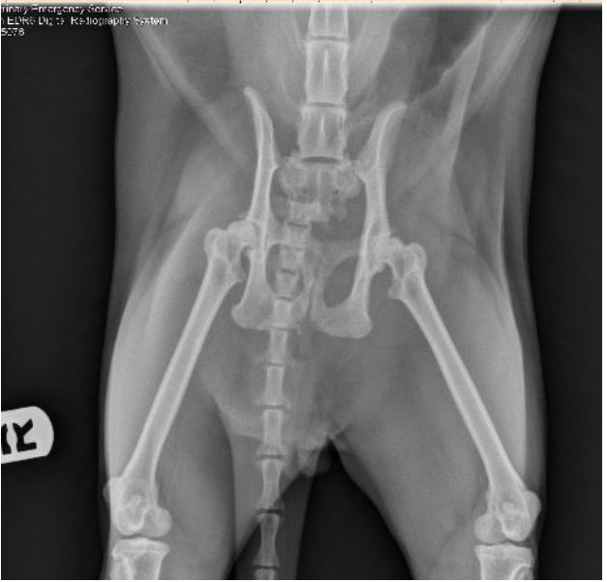

LATERAL 2 RADIOGRAPH
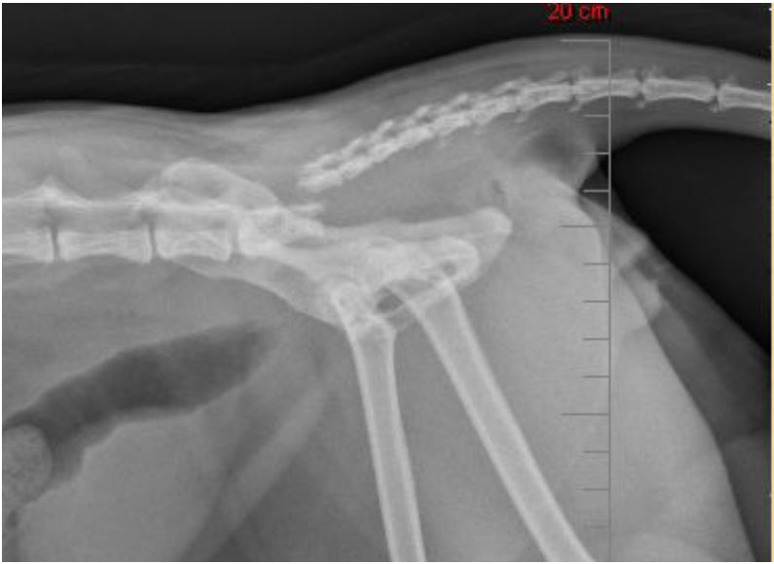

VENTRODORSAL (VD) 2 RADIOGRAPH
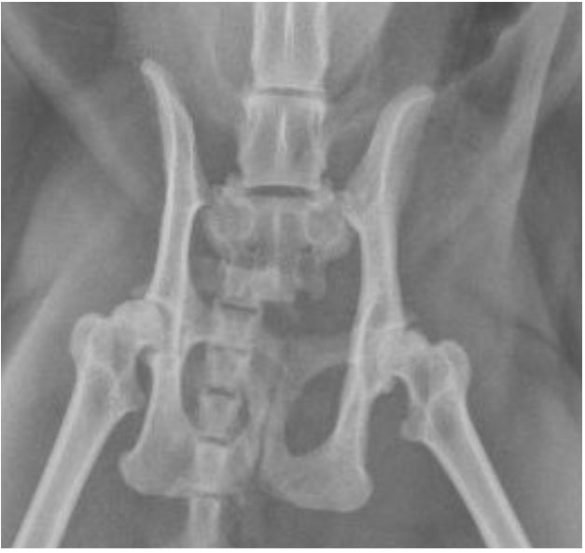

QUESTIONS TO ADDRESS:

1. List the medical diagnostic tests which you would seek to perform to establish this cat’s medical stability – briefly justify each test

2. Develop a problem list for this cat following your initial diagnostics. Be sure to copy your observations into your formulation to document the problems.

3. Develop an initial treatment plan outlining all the steps you would direct your technician to take. List specific drug classes you would employ, if any- using the “Note” feature, briefly justify your treatment.

4. Describe the radiographic findings in this cat (what is not normal, use the imaging anatomy website as a guide)

5. What spinal nerves are potentially affected by the changes visible in the radiographs?

6. What named nerves are potentially affected by the changes visible in the radiographs?

7. What clinical signs would you expect to see; i.e. what organs or muscle groups might be affected based upon your answers?
8. List at least 2 learning issues you encountered in addressing this case. List at least 1 reference (primary references preferred) which helped you address each learning issue.

